− Member1: Use „git status“… what do you see?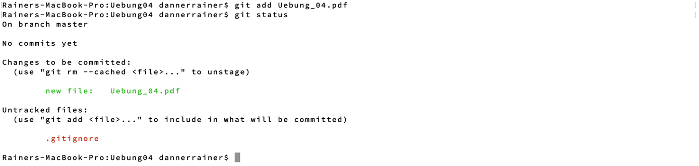

Member2: what is the status? Why does the folder not show as an

untracked file?



Because the folder contains no files which are changed.



After adding files in the folder the folder shows up as not added.

Member1 pull:

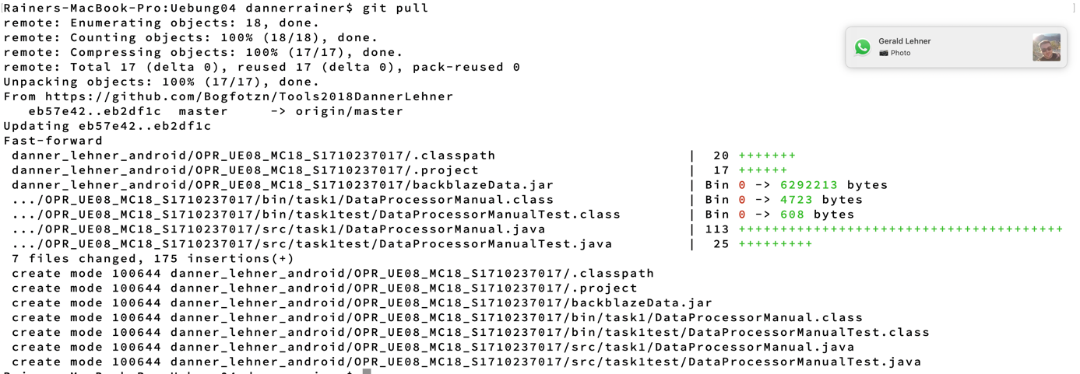

Member2: git pull







Member1: DO NOT COMMIT, only pull. What is the problem and how can you

solve it?

Problem is: Your local changes to the following files would be overwritten by merge

* Solve it manually